Test # | Method | Tool/App | Expected Outcome | Pass/Fail
1 | Create a fabricated XML document to see whether the server can read and parse the required fields for each GPS coordinate reading | server app | Each coordinate entry has all its fields loaded into a structure, including name, MAC, IP, date-time, longitude, & latitude | Pass
2 | Enter fabricated GPS data to see whether the server can turn the data into an XML entry and put it into the XML document from the previous test | server app | A new entry with fabricated data is inserted into the coordinates XML document | Pass
3 | Gather information from the Android client app and send it to the Linux server app to see whether the TCP connection and data transfer is working properly | server app + Android app + strace | The GPS data sent by the Android client is printed out on a terminal on the Linux server | Pass
4 | Gather information from the Android client app and send it to the Linux server app to see whether the sent data is formatted correctly | server app + Android app + strace | The server can parse the information from the client and add that to the XML file in the proper format | Pass
5 | Load the website to see whether it can read from a coordinates XML file and parse the data correctly | web browser | A table listing all coordinate entries is displayed on the web page | Pass
6 | Load the website to see whether it can display all the coordinates read on a Google Map | web browser | The Google Map shows all the coordinates in the XML file as pins on the map | Pass
7 | Click on the "All Current Positions" button to see whether the website can show just the last known position of each unique device | web browser | All unique devices are shown at their last known locations with no duplicates or missing entries | Pass
8 | Enter a valid MAC address and click on the "History Of One MAC" button to see whether the website can show the history of the specified device | web browser | The location history of the device is shown in both table form and as pins on the Google Map | Pass
9 | Enter an invalid MAC address and click on the "History Of One MAC" button to see whether the website can show the history of the specified device | web browser | No history is shown on either the table or on the Google Map, and the website does not crash | Pass
10 | Multiple devices update their position while the website is set to "All Current Positions" mode and automatic refresh is turned off | web browser + server app + Android app | Last known positions of the devices involved are shown on both the table and the Google Map, not updated live | Pass
11 | Multiple devices update their position while the website is set to "History Of One MAC" mode, with a valid MAC address specified, and automatic refresh is turned off | web browser + server app + Android app | The location history of the device is shown in both table form and as pins on the Google Map, with the most recent pin in red and all other pins in green, not updated live | Pass
12 | Multiple devices update their position while the website is set to "History Of One MAC" mode, with an invalid MAC address specified, and automatic refresh is turned off | web browser + server app + Android app | No history is shown on either the table or on the Google Map, and the website does not crash | Pass
13 | Multiple devices update their position while the website is set to "All Current Positions" mode and automatic refresh is turned on | web browser + server app + Android app | Last known positions of the devices involved are shown on both the table and the Google Map, updated live | Pass
14 | Multiple devices update their position while the website is set to "History Of One MAC" mode, with a valid MAC address specified, and automatic refresh is turned on | web browser + server app + Android app | The location history of the device is shown in both table form and as pins on the Google Map, with the most recent pin in red and all other pins in green, updated live | Pass
15 | Multiple devices update their position while the website is set to "History Of One MAC" mode, with an invalid MAC address specified, and automatic refresh is turned on | web browser + server app + Android app | No history is shown on either the table or on the Google Map, and the website does not crash | Pass
16 | A single device updates its position in "GPS" mode while the website is set to "History Of One MAC" mode, with the device's MAC address specified, and automatic refresh is turned on | web browser + server app + Android app | The location history of the device is shown in both table form (no IP, accurate position) and as pins on the Google Map, with the most recent pin in red and all other pins in green, updated live | Pass
17 | A single device updates its position in "Network" mode while the website is set to "History Of One MAC" mode, with the device's MAC address specified, and automatic refresh is turned on | web browser + server app + Android app | The location history of the device is shown in both table form (no IP, inaccurate position) and as pins on the Google Map, with the most recent pin in red and all other pins in green, updated live | Pass
18 | A single device updates its position in "GPS + Network" mode while the website is set to "History Of One MAC" mode, with the device's MAC address specified, and automatic refresh is turned on | web browser + server app + Android app | The location history of the device is shown in both table form (has IP, accurate position) and as pins on the Google Map, with the most recent pin in red and all other pins in green, updated live | Pass

Android Application Testing Screenshots:

Loading the web view: 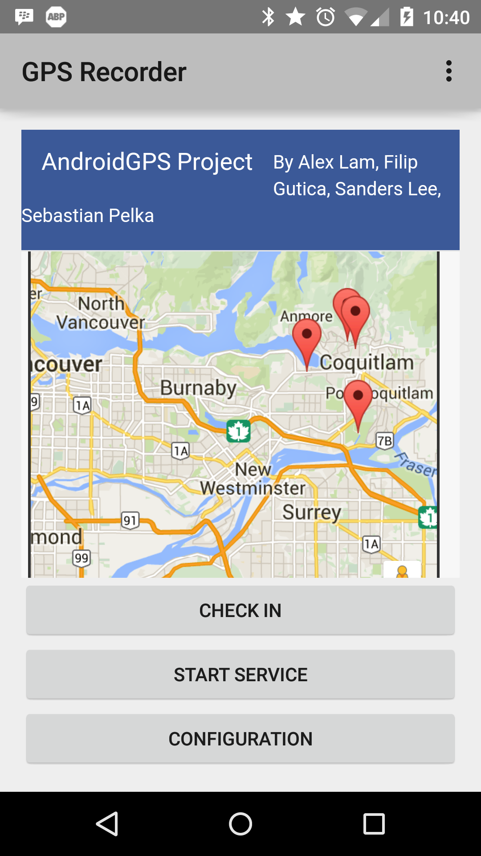

Configuration Fragment
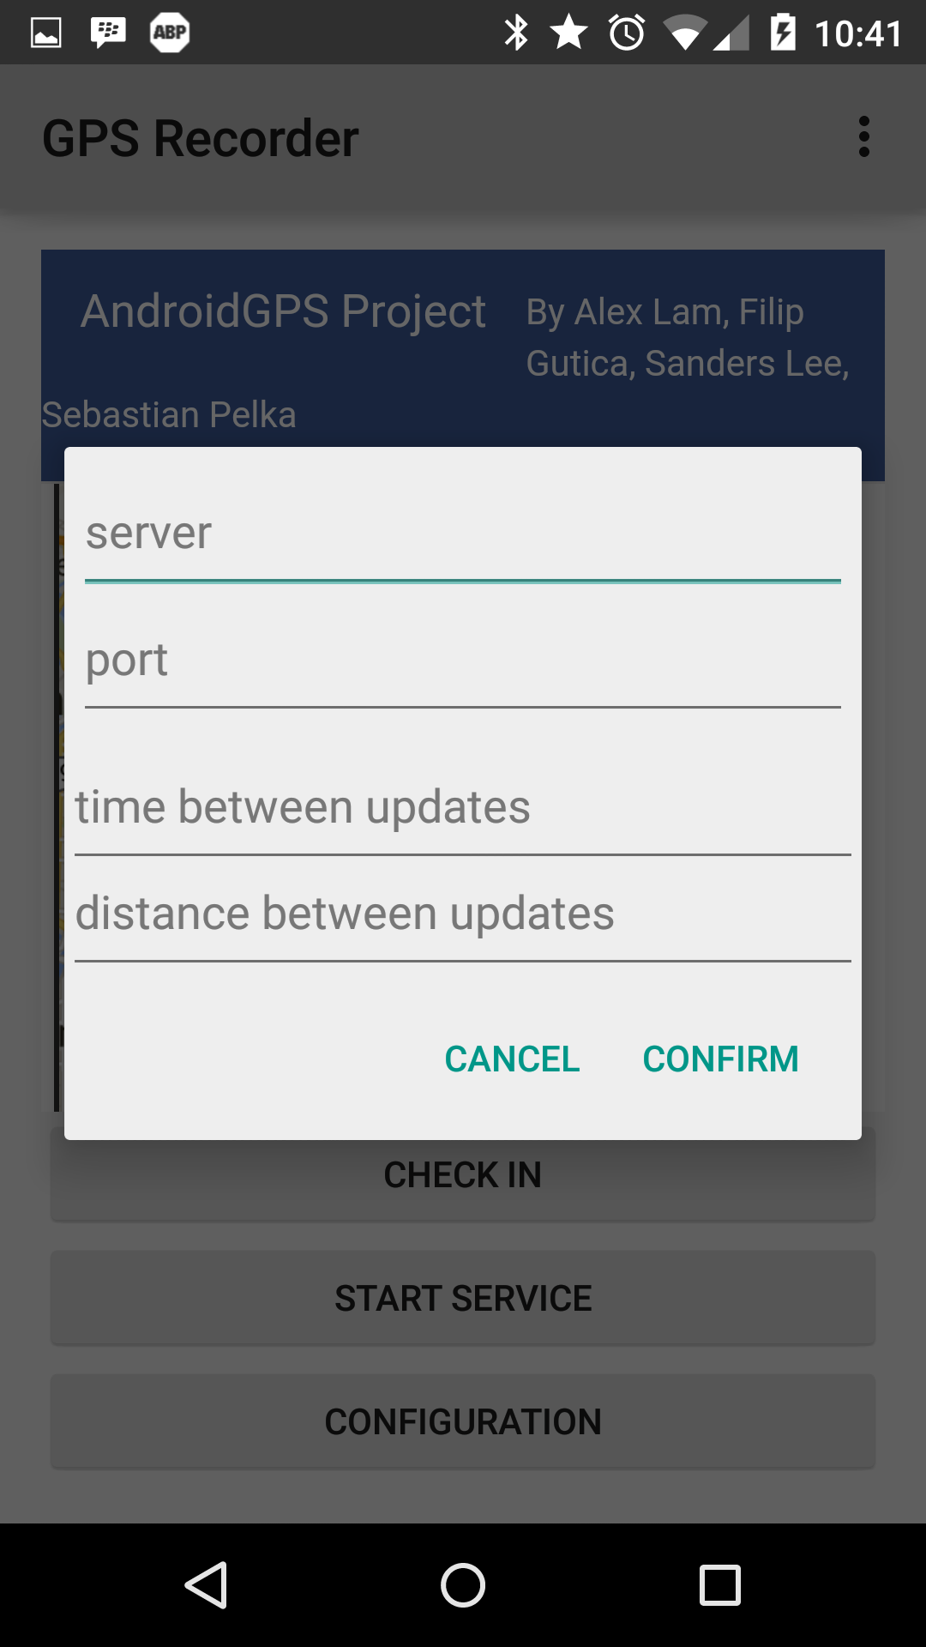

Location mode settings
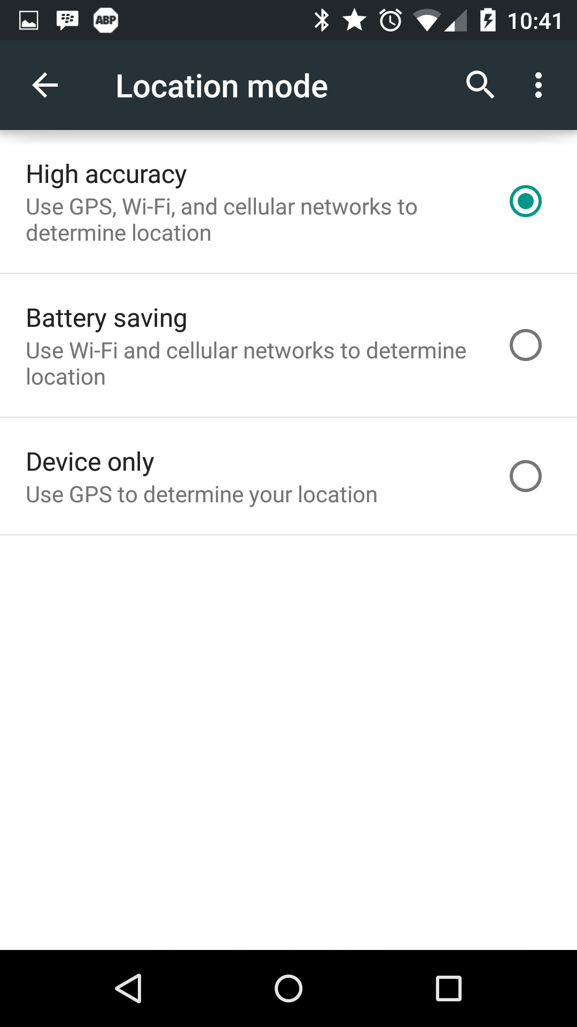

Starting the service
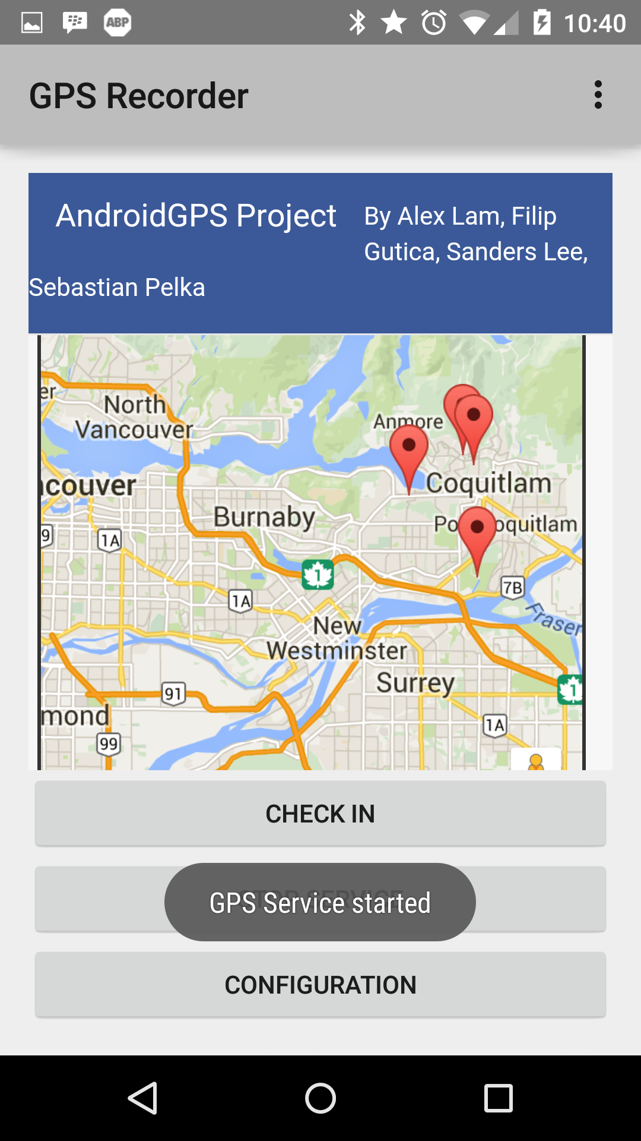

Stopping the Service
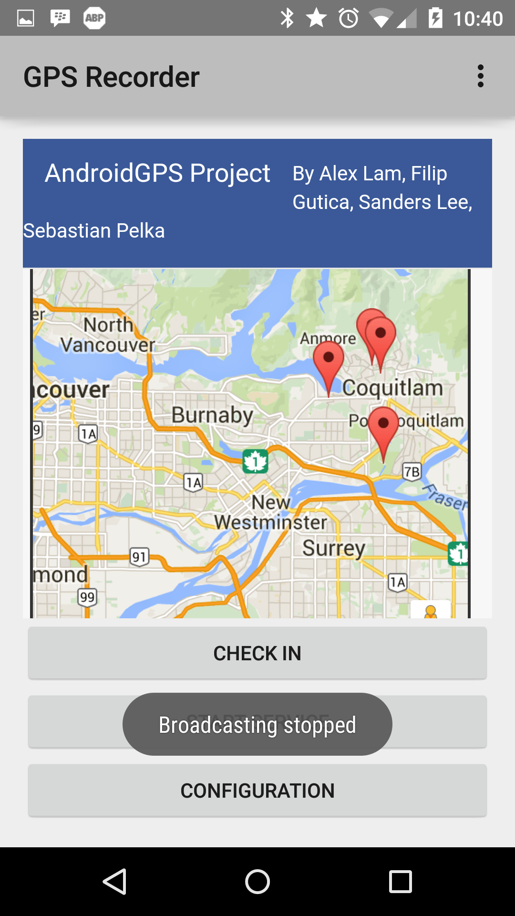

Server Testing Screenshots

Receiving connections and parsing:
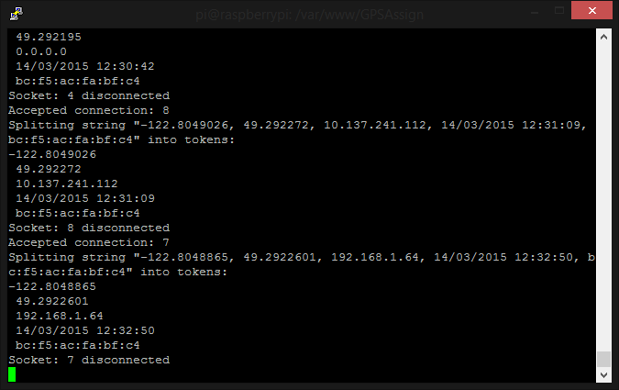

Website Testing Screenshots

View all current positions:
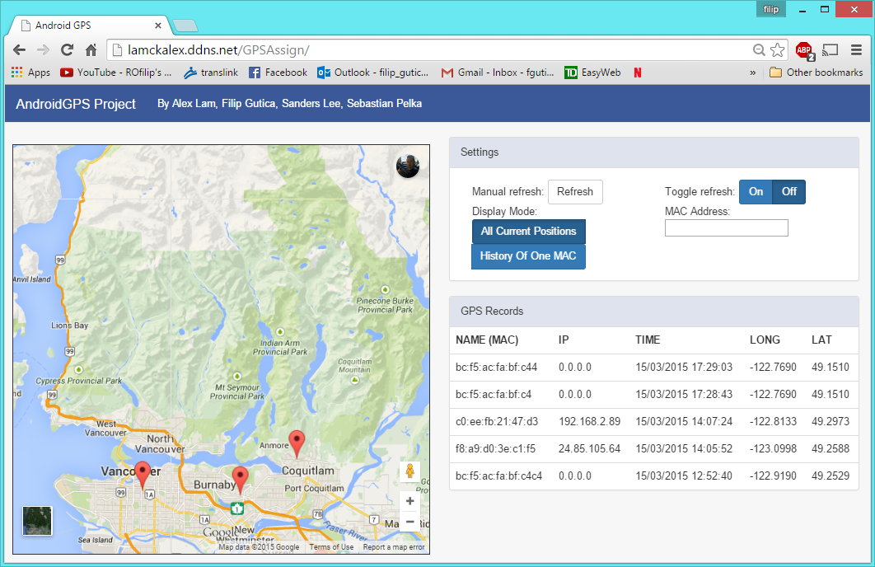

History of one mac address:
